13.Lab 09a Implement Web Apps Student lab manual.

Task 1: Create an Azure web app

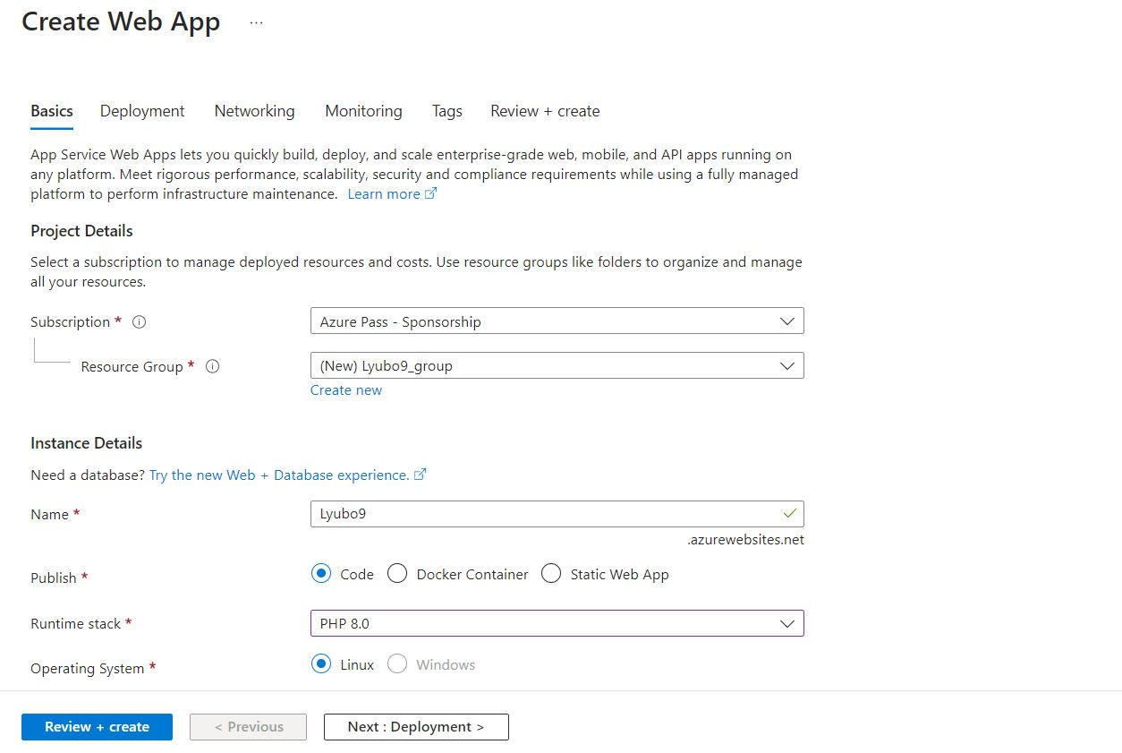

Task 2: Create a staging deployment slot.

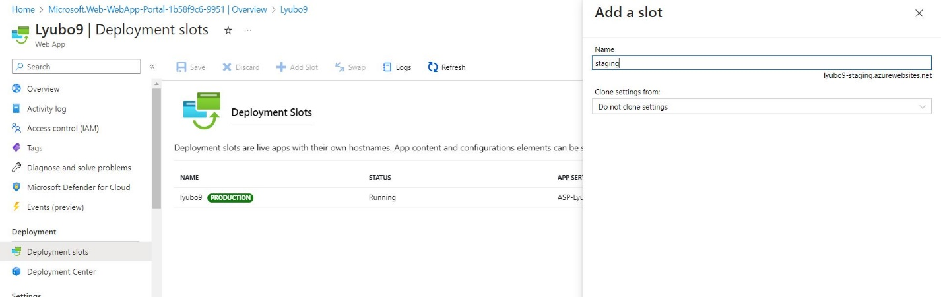

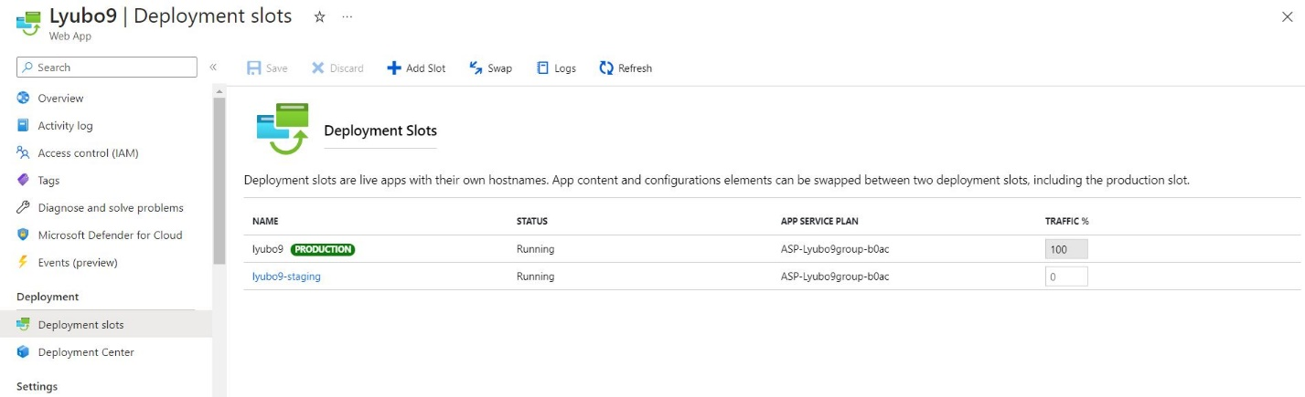

Task 3: Configure web app deployment settings.

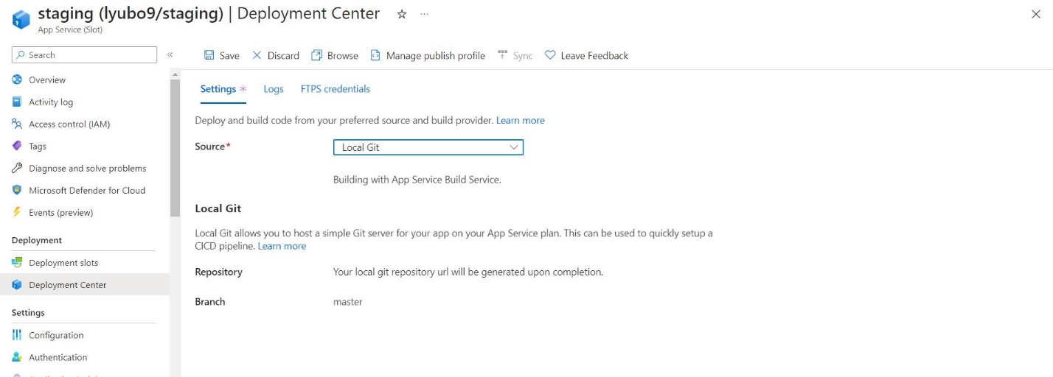

Task 4: Deploy code to the staging deployment slot.

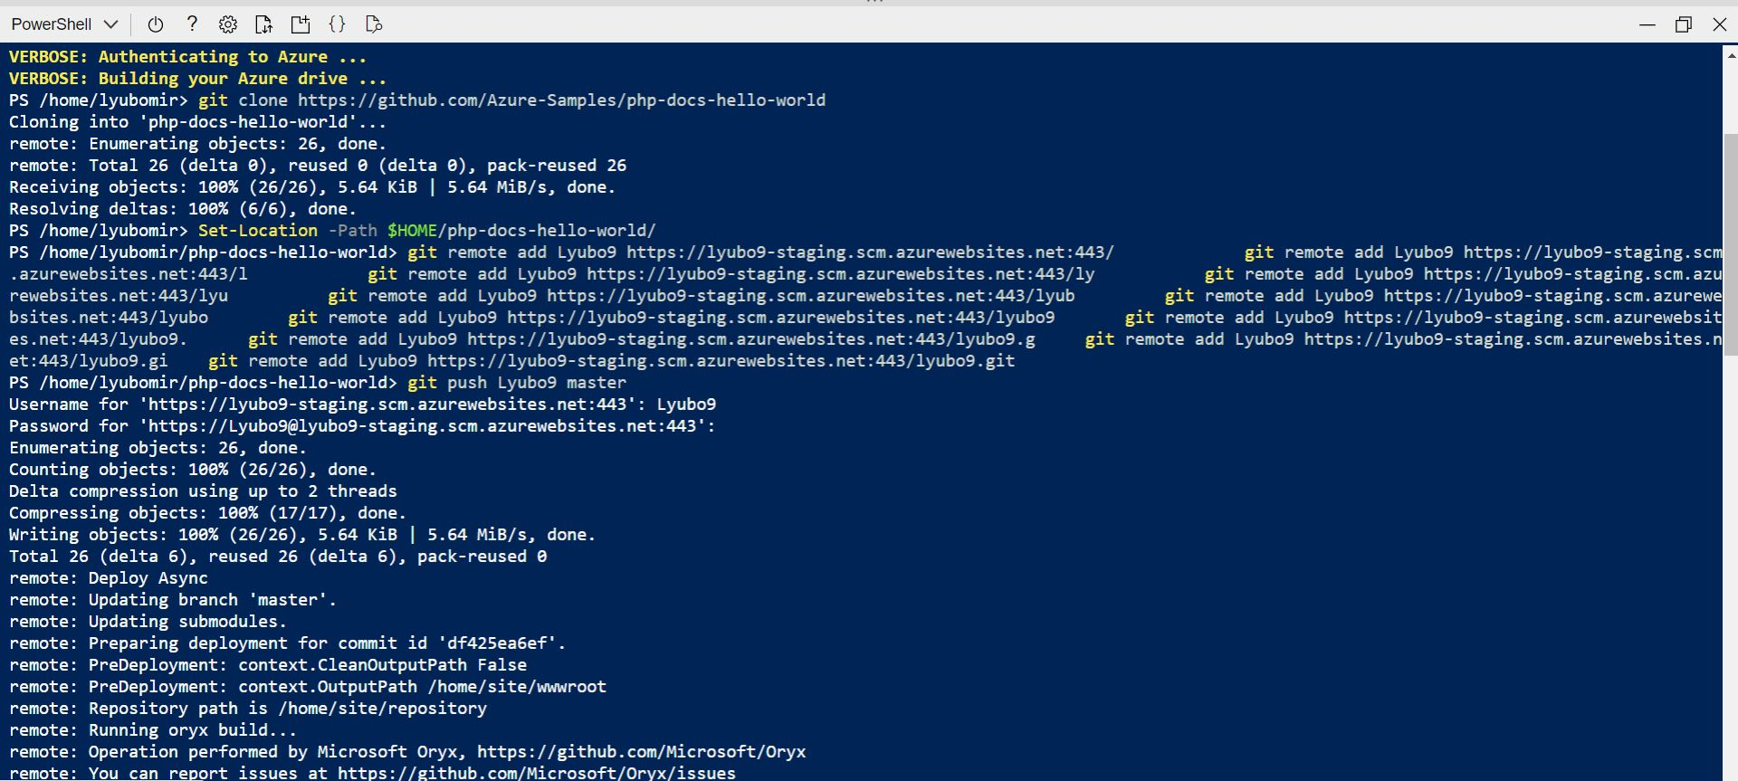



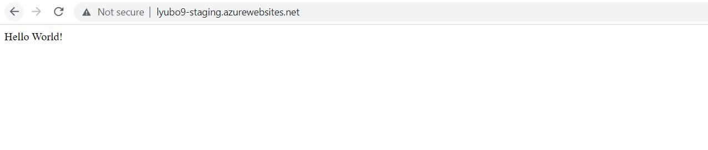

Task 5: Swap the staging slots.

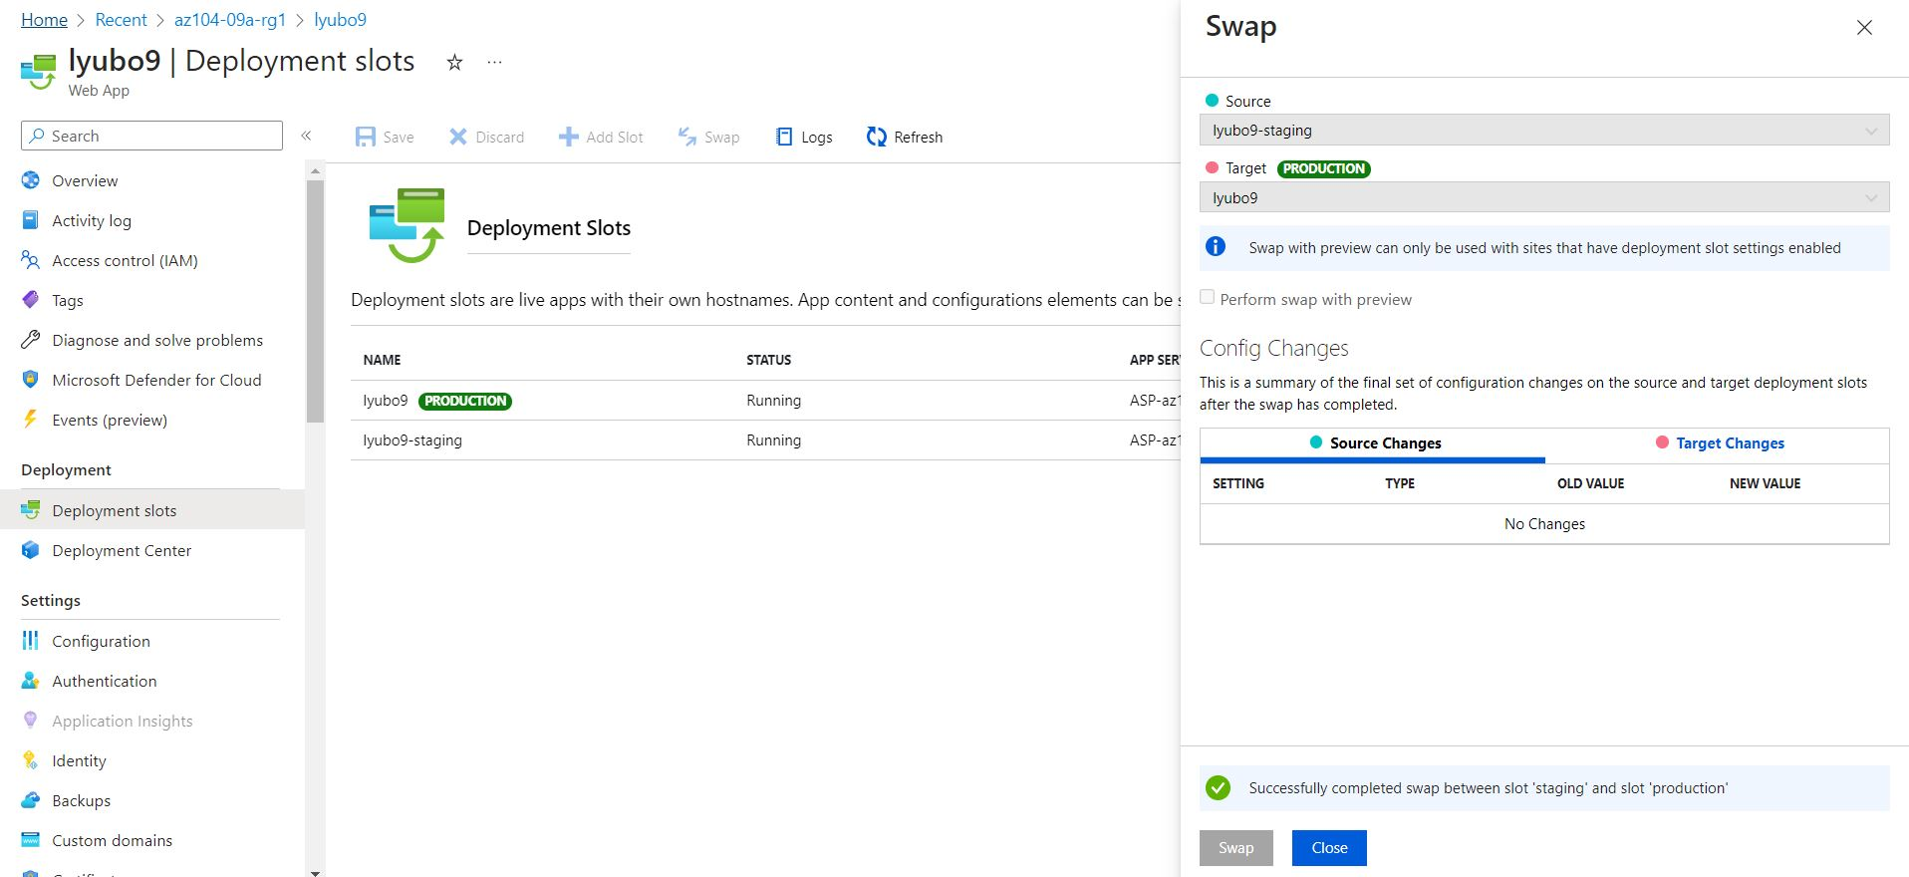

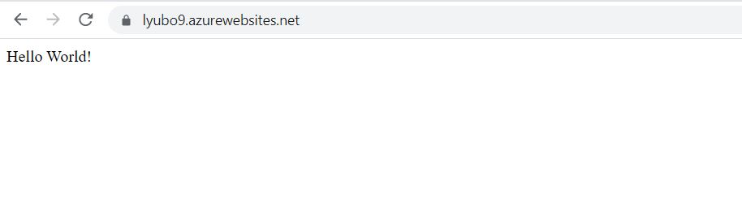

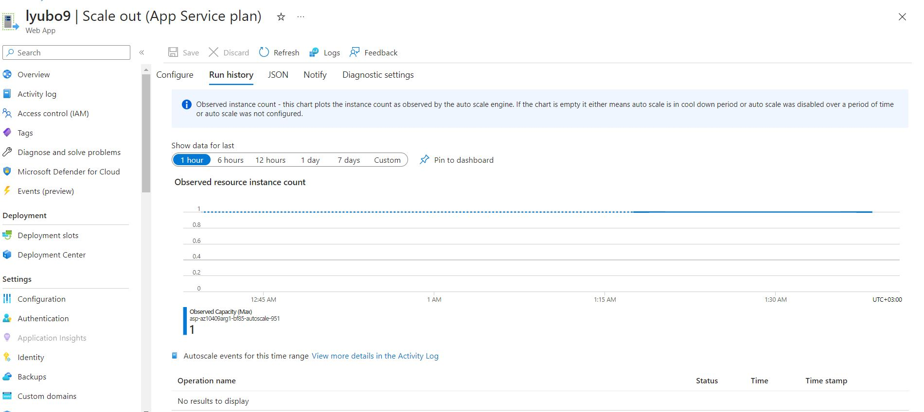

Delete recource.

